PRESENTS

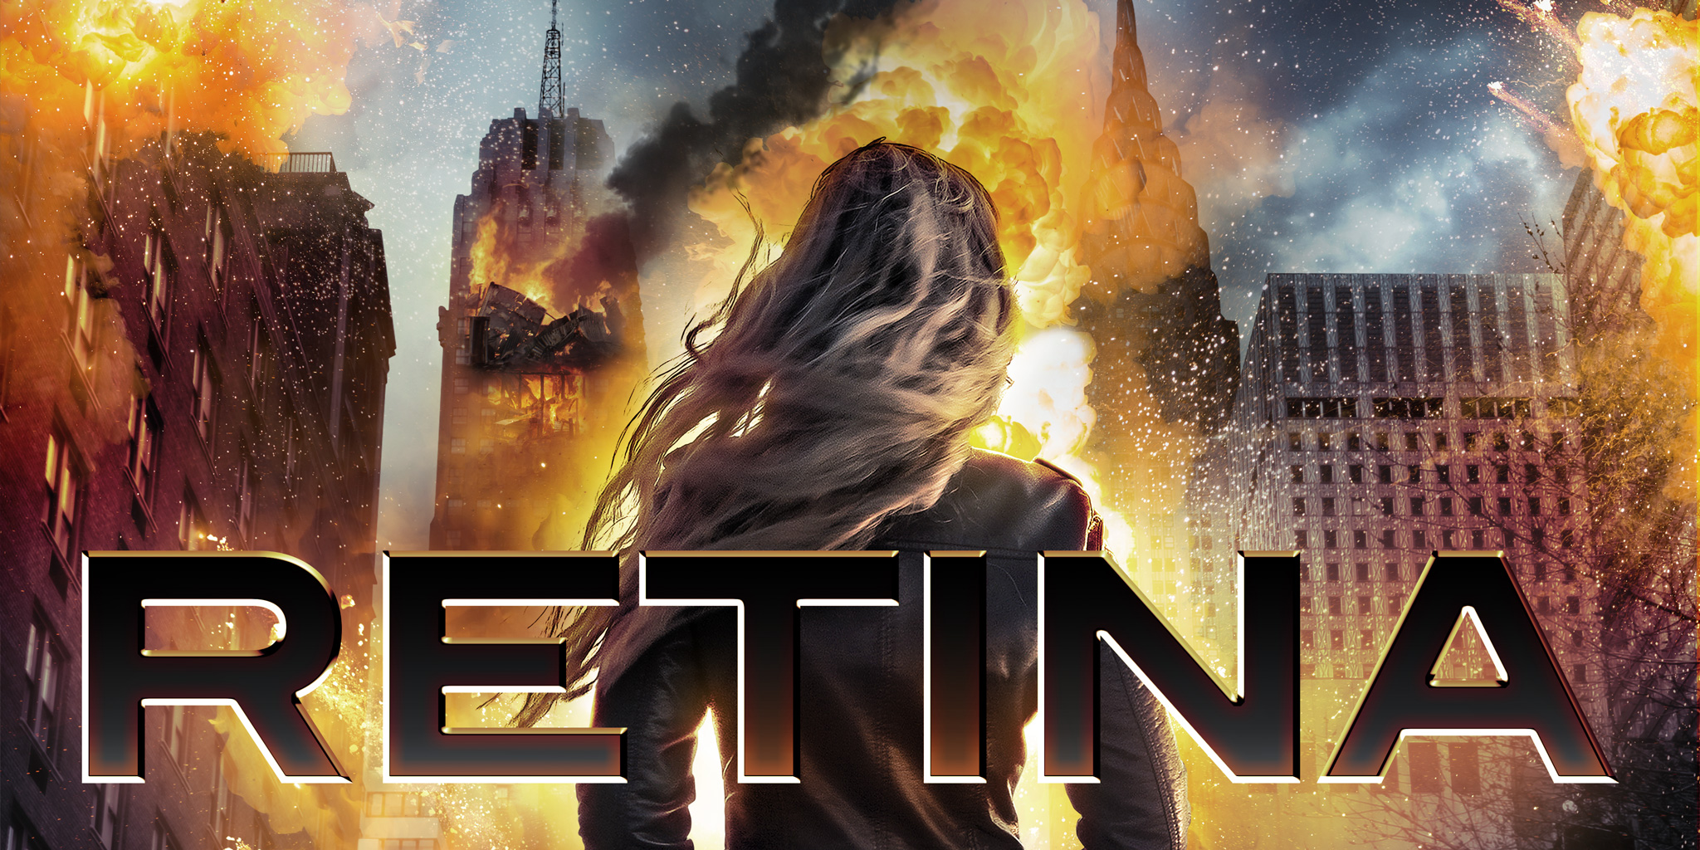

Director: Carlos Ferrer
Cast: Lindsay Goranson, Gary Swanson
Runtime: 87 minutes

Synopsis: A young woman participates in a medical study. After a series of nightmares and unusual side effects, the line between dreams and reality is blurred. She finds herself on the run from those involved, desperate to uncover the truth.

On demand, digital HD and DVD September 4

Trailer: https://youtu.be/HMze42Kboko
Trailer (download): https://www.dropbox.com/s/etccsoy5b5c87nb/Retina_Trailer.mp4?dl=0
Poster: https://www.dropbox.com/s/3063gq9pietew5m/RETINA-C1-RND-2.jpg?dl=0
Stills: https://www.dropbox.com/sh/9wn530xjwkz1p75/AABaIq9XrFYM9IqfG7u7eE0pa?dl=0

