PRESENTS

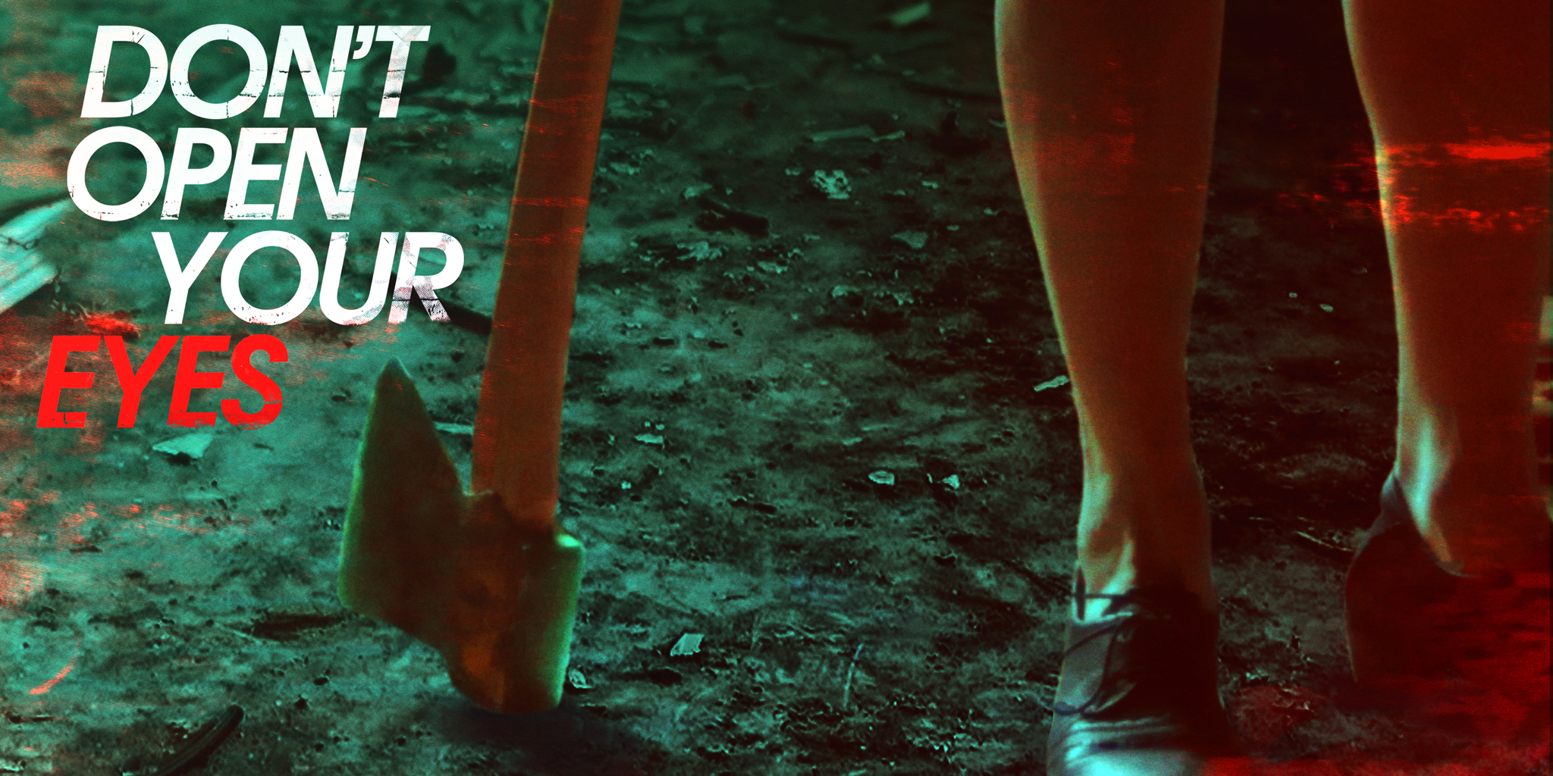

Director: Dmitry Yun
Cast: Jamie Carroll, Tom Kemnitz Jr.
Runtime: 88 minutes

Synopsis: When an apathetic home hospice nurse learns he shares a sinister connection with the mysterious old woman in his care, it forces him to confront a darkness he never could have imagined.

On demand, digital HD, and DVD September 25

Trailer: https://youtu.be/0x8Xlzwyayg
Trailer (download): https://www.dropbox.com/s/ltbcpwwhvz6trcc/DontOpenYourEyes_Trailer_H264_WebReady.mp4?dl=0
Poster: https://www.dropbox.com/s/akjsl3aqldag5f3/DOYE_2x3.jpg?dl=0
Stills: https://www.dropbox.com/sh/t9pnefvf1nu3zs5/AABdGZjwLszIMUBcUWb7J-UVa?dl=0

