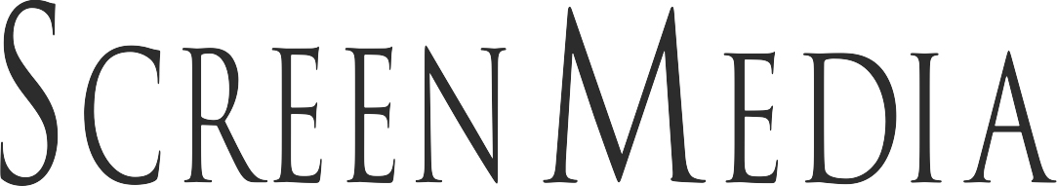

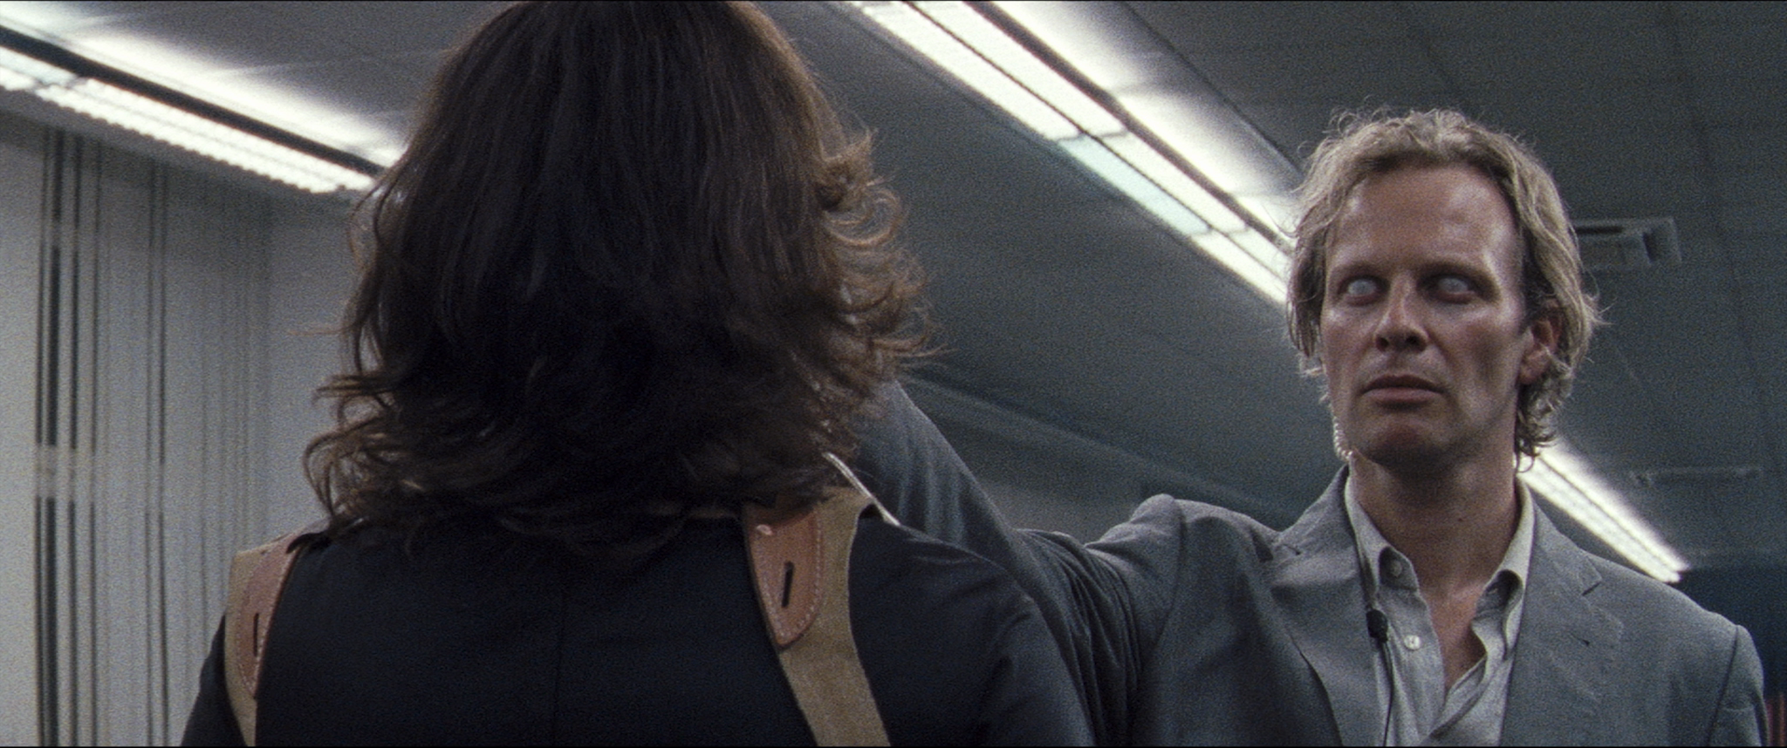

LUZ

Written and directed by: Tilman Singer
Produced by: Dario Méndez Acosta and Tilman Singer
Starring: Luana Velis and Jan Bluthardt.

OFFICIAL SELECTION: Fantasia Film Festival, Fantastic Fest (US Premiere), Berlin International Film Festival, Sitges Film Festival
and many more.

NEW YORK /LOS ANGELES PR Contact:
Emma Griffiths (EG-PR)
E: emma@eg-pr.com
W: www.eg-pr.com

LUZ- SYNOPSIS

LUZ begins as a young female cabdriver (Luana Velis, in the title role) drags herself into a run-down police station. However, a demonic entity follows her there, determined to finally be close to the woman it loves.
Shooting entirely on 16mm, first time feature film director Tilman Singer pays homage to horror masters David Cronenberg, Dario Argento and Lucio Fulci, while infusing the genre with a fresh take of his own.

LUZ- DIRECTOR’S STATEMENT

"LUZ is a story about identity, a lack of one, or maybe even denying one’s own. For the most part this is told by forces (archetypal characters, institutions, or personifications of moral arguments) influencing and manipulating our titular character Luz. I structured the narrative as a panic attack, of repressed memories and confusion. It is purposely open to interpretation by the viewer.

LUZ is a sensuous thriller that plays with the sensory perception of the audience. Initially, I wanted to write a simple story that could only be told audio-visually. How we ended up telling it cinematically, nested within diegetic flashbacks, got a little more complicated. For example, we use an additional layer of sound that adds a past reality to a present one. Given that we are observing a moment relived under hypnosis, the credibility of both realities is questioned at all times. The viewer who attempts to answer this question of credibility has to, with sharpened senses, fully engage in image and sound.

LUZ is my first feature film and at the same time the project for my diploma at the Kunsthochschule für Medien Köln/Academy of Media Arts Cologne. Dario Méndez Acosta (production design), Paul Faltz (DOP), Simon Waskow (original music) and Henning Hein (sound design, mixing) worked with me on LUZ and have been involved in each of my recent films."

FILMMAKER TILMAN SINGER

LUZ- FILMMAKER BIOGRAPHY

TILMAN SINGER- WRITER/ DIRECTOR

Tilman Singer was born in Leipzig, Germany in 1988. He produced stop motion animation short films and commercials in the USA, France and Germany before he began his studies at the Academy of Media Arts Cologne in 2011. He has directed several short films, commercials, music videos. His debut feature film LUZ screened at the Berlinale, in addition to Fantastic Fest, Fantasia Film Festival and Sitges Film Festival, before an upcoming worldwide release.

LUZ- CAST BIOGRAPHIES

LUANA VELIS- LUZ
Luana Velis studied acting in Bochum, Germany. She won her first award from the Theater Festival of German Acting Students for her role in “Nothing New in the West.” Her work in theater includes regular roles for Schauspielhaus Bochum in 2016/17 and Schauspiel Frankfurt since 2017.

She has worked with directors Jan-Christoph Gockel, Hasko Weber, Roger Vontobel, Julia Hoelscher, Marius von Mayenburg and Viktor Bodo and is a regular voice actor for TV channels SWR, WDR and HR.

LUZ represents her first starring role in a feature film and screened at the Berlinale, in addition to Fantastic Fest, Fantasia Film Festival and Sitges Film Festival, before an upcoming worldwide release.

JAN BLUTHARDT- DR. ROSSINI

Jan Bluthardt was born 1978 in Temuco (Chile) and received his acting degree from the Westfälische Acting School in Bochum, Germany. He started in his career in theater, at Schauspielhaus Bochum and Schauspielhaus Leipzig while still enrolled in acting school. In 2006, he became one of Theater Basel´s company members and worked with directors such as Anna Viebrock, Werner Duggelin and Elias Perrig. He worked for Schauspielhaus Zürich in 2009 where he acted in productions by Barbara Frey, Clemens Sienknecht, Ruedi Häusermann, Stefan Pucher, Sebastian Baumgarten, René Pollesch, Sebastian Nübling and Herbert Fritsch.

His recent film and television work include the TV series “Tatort” and Tilman Singer’s LUZ, which screened at the Berlinale, in addition to Fantastic Fest, Fantasia Film Festival and Sitges Film Festival, before an upcoming worldwide release.

JULIA RIEDLER- NORA

Julia Riedler was born in Salzburg, Austria, in 1990 and studied acting at Hamburg’s Hochschule for Music and Theater. She worked as a performance curator for the MS Dockville Festival for Art, Music in Hamburg and has been a member of the artists’ network cobratheater.cobra since 2009. During her last year as an acting student, she worked for the prestigious Deutsches Schauspielhaus Hamburg and received the Boy-Gobert award for outstanding performance by an actor in 2013.

From 2013 to 2015, she was a member of the acting company at Schauspiel Köln. She has contributed to numerous radio plays and appeared in various film and television productions in Germany and Austria. Riedler has been a member of the acting company of Münchner Kammerspiele since 2015. She was voted Best Young Actress and Munich’s Best Actress in 2016 and received the renowned Bavarian State Arts Award in 2017.

Tilman Singer’s LUZ is her most recent theatrical film role, which screened at the Berlinale in addition to Fantastic Fest, Fantasia Film Festival and Sitges Film Festival, before an upcoming worldwide release.

LUZ- CAST & CREW LIST

CAST

Nesche Fröhlich Bargast
Boris Maximov Bargast
Keshav Purushotham Barmann
Nadja Stübiger Bertillon
Jan Bluthardt Dr. Rossini
Kate Dervishi Fluzghafendurchsage
Uwe Michael Witzel Hausmeister
Luana Velis Luz
Lilli Lorenz Margarita
Julia Riedler Nora
Johannes Benecke Olarte
Reinhard Singer Polizist am Empfang
Levin Krasel Werbespot Darsteller
Adrian Witzel Werbespot Darsteller
Luisa Stricker Werbespot Darsteller
Fidel Bums Werbespot Darsteller
Thomas Lambertz Werbespot Darsteller
Omid Tabari Zentrale

CREW

Tilman Singer Writer/ Director

Adrian Witzel 1st AD
Stephanie Englert 1st camera assistant
Eva Hoffmann 1st camera assistant
Paul Reinholz 1st camera assistant
Felix Schon 1st camera assistant
Lisa Bülow 2nd camera assistant
Tobias Löhde 2nd camera assistant
Milan Lukas Fey Art Department Assistant
Alexander Pascal Forré Art Department Assistant
Semih Korhan Güner Art Department Assistant
Denis “Pony” Hoffmann Art Department Assistant
Paula Pedraza Art Department Assistant
Moritz Pflüger Art Department Assistant
Benjamin Ramírez Pérez Art Department Assistant
Hermes Villena Art Department Assistant
Nesche Fröhlich Art Department Assistant
Fidel Bums Art Department Assistant
Thomas Lambertz Art Department Graphics
Nicolas Künzer Boom Operator
David Wesemann Boom Operator
Fabiana Cardalda Colorist
Stanislava Milenkova Costumes
Analena Razborsek Costumes Assistant
Ewald Hentze DCP
Paul Faltz Director of Photography
Fabian Podeszwa Editor / Props
Mikishan Amalaratna Electrician
Ronny Balcazar Electrician
Oliver Freuwörth Electrician
André Hörmeyer Electrician
Filip Jacobsen Electrician
Basia Napora Electrician
Luca Oltenau Electrician
Ekbal Sadid Electrician
Arne Schramm Electrician
Luisa Stricker Executive Producer
Mario Von Grumbkow Executive Producer
Christoph Otto Floor Manager
Julian Pawelzik Floor Manager
Mehmet Büyükatalay Floor Manager / Sound Mixer
Christian Godau Gaffer
Yves Maurice Itzek Gaffer
Can Köprülü Gaffer
Alexander Pauckner Gaffer
Konrad Zimmermann Gaffer
Michel Dulisch Grip
Johanna Hübner Grip
Rudeina Konstantini Make-up
Jennifer Uhlig Make-up Assistant
Tilman Singer Producer / Writer / Director / Editor
Dario Méndez Acosta Producer Production Design
Marion Eisenmann Production Assistant
Michelle Blum (ex Heipel) Production Assistant
Luca Röser Production Assistant
Boris Maximov Production Assistant
Lena Sofia Varas Arévalo Production Design Assistent
Oliver Diez Rear Projection Operator
Hannah-Lisa Paul Script Supervisor
Kim Lêa Sakkal Script Supervisor
Waldemar Kempf Script Supervisor / Art Department Assistant
Albi Fouché Script Supervisor / Electrician
Lilian Villalba Script Supervisor / Foley Artist
Jonas Lux Sound Design
Steffen Pfauth Sound Design / Sound Editor / Foley Recording
Henning Hein Sound Design / Sound Mixing / Dialogue Editor
Alexandros Topalis Sound Edit
Simon Waskow Sound Mixer
Silvia Juliana Tovar Quintero Spanish Translation
Nathan Schönewolf Set Designer
Hanieh Bozorgnia Set Design Assistant
Edgar Arias Title Design
Patrick Buhr VFX

MUSIC DEPARTMENT

Belén Rurales Aguilar Cello
Marvin Horsch Drum Recording
Niklas Wandt Drums
Sophia Spies Lyrics / Vocals / Vocal Recording
Simon Waskow Music Composer
Jonathan Kastl Music Mixing / Recording
Daniel Westbrock Percussion
Noah Zeldin Saxophon
Sophie Rasmussen Viola
Isaac Andrés Espinoza Hidrobo Violin
Hanitra Wagner Violin
Thomas Meckel Vocals

