Presents

LIAM GALLAGHER: AS IT WAS

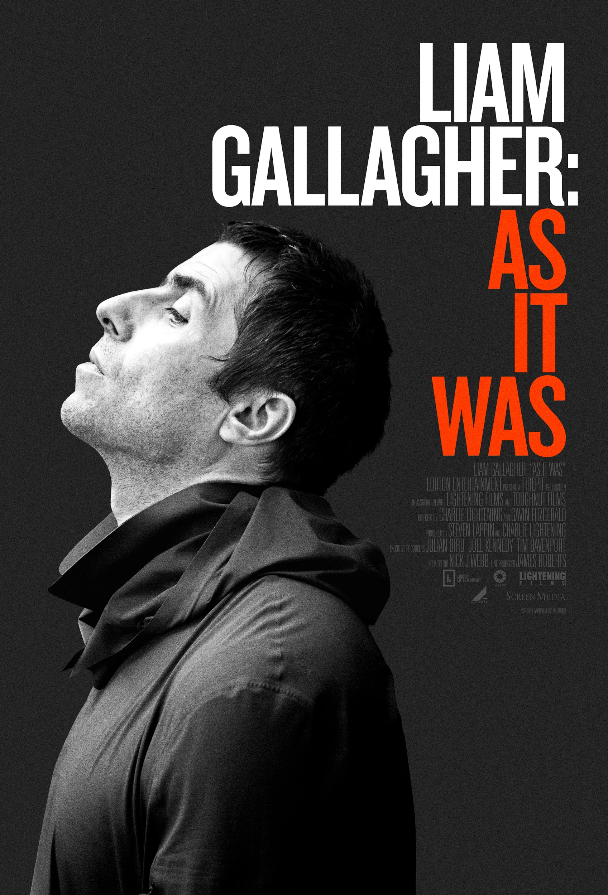

In Theaters September 13, 2019
Available on Digital HD on Sept 17, 2019
Available on VOD Platforms on October 8, 2019

Why Me? Why Not.
Liam Gallagher’s Upcoming Solo Album out September 20, 2019

Website
Press Materials

For More Information Please Contact:
AprilTonsil@FalcoInk.com / EricaAbrams@FalcoInk.com / JulietBasraoui@FalcoInk.com
Falco Ink.
212-445-7100

LOGLINE

The story of one of the greatest frontmen of all time, LIAM GALLAGHER: AS IT WAS charts the dizzying heights and bitter lows of an artist who defines what it is to be a rock and roll star.

SYNOPSIS

LIAM GALLAGHER: AS IT WAS tells the honest and emotional story of how one of rock music’s most electrifying frontmen fell from the dizzying heights of his champagne supernova years as part of the band Oasis into a musical wilderness of ostracism, booze, and bitter legal battles. In his own words, hear how Liam fought his way back, turning his fall from superstardom into the launch of a visionary solo career.
With unparalleled access to every area of his life, directors Charlie Lightening and Gavin Fitzgerald invite us backstage for a no-holds-barred look at one of the most talked-about and charismatic artists of his generation

DIRECTOR’S STATEMENT

CHARLIE LIGHTENING: Having known Liam both personally and creatively over the past 10 years, to see him back where he should be, and to see the reaction to him once again has been fantastic. For Liam to let me in, to be there to capture it all, up close and personal and to tell the whole story in his own words makes for an amazing film. One of the greatest rock n roll comebacks of all times and you are there with him each step of the way.

GAVIN FITZGERALD: Love him or loath him, Liam has an undeniably magnetic pull to the camera. From a very young age, his aura was inscribed into popular culture and it never disappeared, it just lay dormant. There's a need for this last standing rock & roll star and that is exemplified in the cross generational and dedicated fanbase he has. Whatever Liam does, they follow and it's incredible to watch. This film is an honest representation of Liam focusing on a period in his life that not many people know about.

PRODUCER STATEMENT

STEVEN LAPPIN: “As It Was” started initially as a behind the scenes making of Liam’s debut solo record. Working very closely with his long-term friend and personal film maker, Liam invited Charlie Lightening and later Gavin Fitzgerald to chronicle this fascinating turbulent chapter of his life.

With unprecedented access to Liam, this was a very unique opportunity to make a very special film in which Liam was able to tell his own story in his own words for the very first time. Exploring all areas of his life, this allowed us to craft a film which revealed the true man behind the image, illustrating a side of the man which has never been seen before.

Being able to tell the story of one of the most original and authentic personalities in the history of music during this period of reinvention was a fascinating journey and a very rare opportunity in modern filmmaking.

FEATURED CAST

LIAM GALLAGHER: The electrifying presence, the mesmeric charisma, the audacious swagger, the incomparable way of singing lyrics that captured the zeitgeist and sound-tracked their times and beyond…perhaps more than anyone else, Liam Gallagher showed what it was like to be a real rock star in a band that conquered the world.

But all that was in the Nineties. In the years that have followed, Liam Gallagher has struggled to define his role, ricocheting between projects in fashion and music while fighting his own personal demons all against the backdrop of an artist cast into the musical wilderness. Bitter legal battles, a seemingly eternal feud with his brother Noel, lethargy and boredom, lack of direction, booze, relationship troubles, the baiting from the celebrity circus, social media and a restless press: what do you do if you once stood on the peak of the mountain, but now can’t reach the first base?

“AS IT WAS” will tell the emotional story of how Liam went from the dizzying heights in the Champagne Supernova years to a life drifting in the shadows, ostracized by the music industry and eclipsed by the acclaim for his brother’s Oasis after-life.

For the last year, Liam has allowed Directors’ Charlie Lighting and Gavin Fitzgerald full access to his life as he embarks on his biggest challenge both personally and professionally since Oasis imploded– finding out who he is as both a man and an artist, risking everything he has on a new solo career that strips everything back to its musical core, and finding his own authentic voice.

And, in this film and for the first time ever, Liam tells his own story in his own words – outspoken, opinionated, unmediated and unrestricted. Nothing is off limits as Liam lays it out about all aspects of his life in his characteristic style…a combination of candor, humor and devastating honesty.

It’s set to be a fascinating and intimate portrait of one of Britain’s true rock ‘n’ roll originals.

FILMMAKER BIOS

DIRECTOR – CHARLIE LIGHTENING: Charlie is a director/producer working predominately within the music industry making documentaries, music promos and live performance films.

He has made films for artists such as Paul McCartney, Nile Rodgers, Noel Gallagher, Ronnie Wood, Robbie Williams, Bjork, Black Sabbath, Jamiroquai, Kasabian, to name a few. His last motion picture, 12/12/12 which he produced with the Weinstein company was executive produced and starred Paul McCartney as well as The Rolling Stones, The Who, Bruce Springsteen and Roger Waters. His first US theatrical release to great critical success. He also Produced the live 12/12/12 concert, which was watched by over 20 million people across the US.

Having worked with Paul McCartney for the last 10 years documenting him on the road, Charlie has made numerous films with him. A particular highlight 'Paul McCartney - In Performance at the White House', with an ongoing feature documentary hoping to be his next project. Charlies strength has always been gaining the trust of these stars and in turn the access he gains is unique. His journey has come full circle with his relationship with Liam Gallagher, and to be around to capture one of the biggest rock n roll comebacks ever has been an amazing experience

DIRECTOR – GAVIN FITZGERALD: Gavin FitzGerald’s first feature length documentary, Conor McGregor: Notorious, was the highest grossing Irish documentary of all time. The film was distributed by Universal Pictures and had a worldwide cinema release. This was a four year long project that built on the tremendous success of his television series documenting the rise of the controversial Irish UFC fighter. Gavin is from Dublin, Ireland but regularly travels abroad pursuing new and exciting stories with broad cinematic appeal. He has a number of new films in development as well as the recently completed Liam Gallagher: As It Was documentary which charts Liam Gallagher's musical journey - post the infamous Oasis split.

PRODUCER – STEVEN LAPPIN: Steven is an independent producer working in television, film and theatre. His recent work includes producing feature documentary films for “Freedom “for George Michael which tragically was to be George’s final piece of work, and now Liam Gallagher’s “As It Was”. He is the originating producer of “Girl from the North Country” the Olivier award winning theatre show based on the music of Bob Dylan. Steven has produced acclaimed music specials A Night with Beyoncé, One Night with Rod Stewart, An Audience with Neil Diamond. For many years he series produced the talk show Parkinson and many other iconic entertainment shows. In addition, Steven has a proven track record in show-running iconic entertainment series and global events such as One Love Manchester. He produced the motion picture “Springsteen and I” for cinematic release, documentaries Joanna Lumley: Elvis and Me, Dara O’Brian Meets Stephen Hawking, and most recently Sheridan Smith “Coming Home”.

OPENING CREDITS

Lorton Entertainment Presents
A Firepit Production
In association with Lightening Films
and Toughnut Films

As It Was

CLOSING CREDITS

Directed by
Charlie Lightening

Directed by
Gavin Fitzgerald

Produced by
Steven Lappin

Film Editor
Nick J Webb

Line Producer
James Roberts

Art Director
Dylan Kendle

Executive Producers Lorton Entertainment
Julian Bird
Joel Kennedy
Tim Davenport

Archive and Title Post Production
Jon Hollis/Raised By Wolves

Archive Producers
Cath Pick
Martyn James
Daniel Dempster

Assistant Producer
Hilary Whitley

Music Supervisor
Jane Bridgeman

Directors of Photography
Dan Lightening
J J Rolfe
Jaimie Gramston
David Meadows

Sound Recordists
Chris Wright
Stuart Windle
Ricky Barber

Camera Operators
Dan McPake
Paul Bugler
Sean Lomax
Ben Worthington
Peter Gregory
Ben Hanratty
Darragh McCarthy
Martin Lightening

Gaffer
Phil Hurst

Drone Operator
Visual Skies

Steadycam Operator
Simon Wood

Focus Puller
Joe Wright

Assistant Camera
Eugen Ebanca

Production Assistant
Hannah Bush Bailey

Production Runner
Ola Soyemi
Cullen Farleigh

DIT
Ross Craig
Lewis Abbott

Make Up Artist
Pamela Cochrane

US Location Manager
Skoti Collins

Assistant Editor
Alex Ford

DI Producer
Marie Valentino

Halo Post Head of Film
David Turner

Re-Recording Mixer
John Rogerson

Online Editor
Andrew Penfold

DI Colourist
Katherine Jamieson

DI Assistant
Edward Corrigan

Producer
Charlie Lightening

Line Producer
Octavia Landy

Contributors
Debbie Gwyther
Paul Gallagher
Peggy Gallagher
Lennon Gallagher
Gene Gallagher
Molly Moorish
Bonehead
Phil Christie
Mike Smith
Jay Mehler
Drew McConnell
Mike Moore
Dan McDougall
Dan Grech-Marguerat
Christian Madden
Jo Whiley
Ted Kessler
Sam Eldridge
Katie Gwyther
Amy Williams
MistaJam
J J Finan, Charlestown
Aurelio Reyes “El Gallo De Chiapas”

U Rock Management
Sam Eldridge
Roy Eldridge
Kate Hardwick
Fred Lane-Fox

Warner Music UK
Phil Christie
Jennifer Ivory
Alex Burford
Peter Breeden
Max Gore
Cara-Louise Gourlay

Lorton Entertainment
Joseph Berry Jr
Angus Carlill
Jason Mackay
Ben Gallop
Arthur Landon
Ed Barratt
Dave Shear
Tommy Gordon
Abi Gadsby
Angus Paskin Orr

Legal
Will Lyons
Delphine Seddon
James Radice
Sam Tatton-Brown
Alastair Mavor
Antony Swiatek
Nicki Parfitt
Andy Lee
Christos Michaels
Johan Ewing

Accountants
Mark Witt

Archive
Getty Images
BBC
Screen Ocean
AP Archive
So Television
Videoplugger
Splash
STV
Tim Abbott

With Thanks to
Air Studios
Richard Prestage
Camden Studios
Z Studios
Liz Stirling
Get Chauffeured
Promotive
Ben Pomphrett
Ben Challis/Glastonbury
McGowan Transcriptions
Henry Normal
Claire Hagger
Zap Studios

With Special Thanks to
Andrew Billett
Andrew & Elizabeth Bowman
Nick Robinson
Neil Robertson
James Holdsworth
Simon Champ

