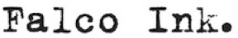
PRESENTS
PORTALS
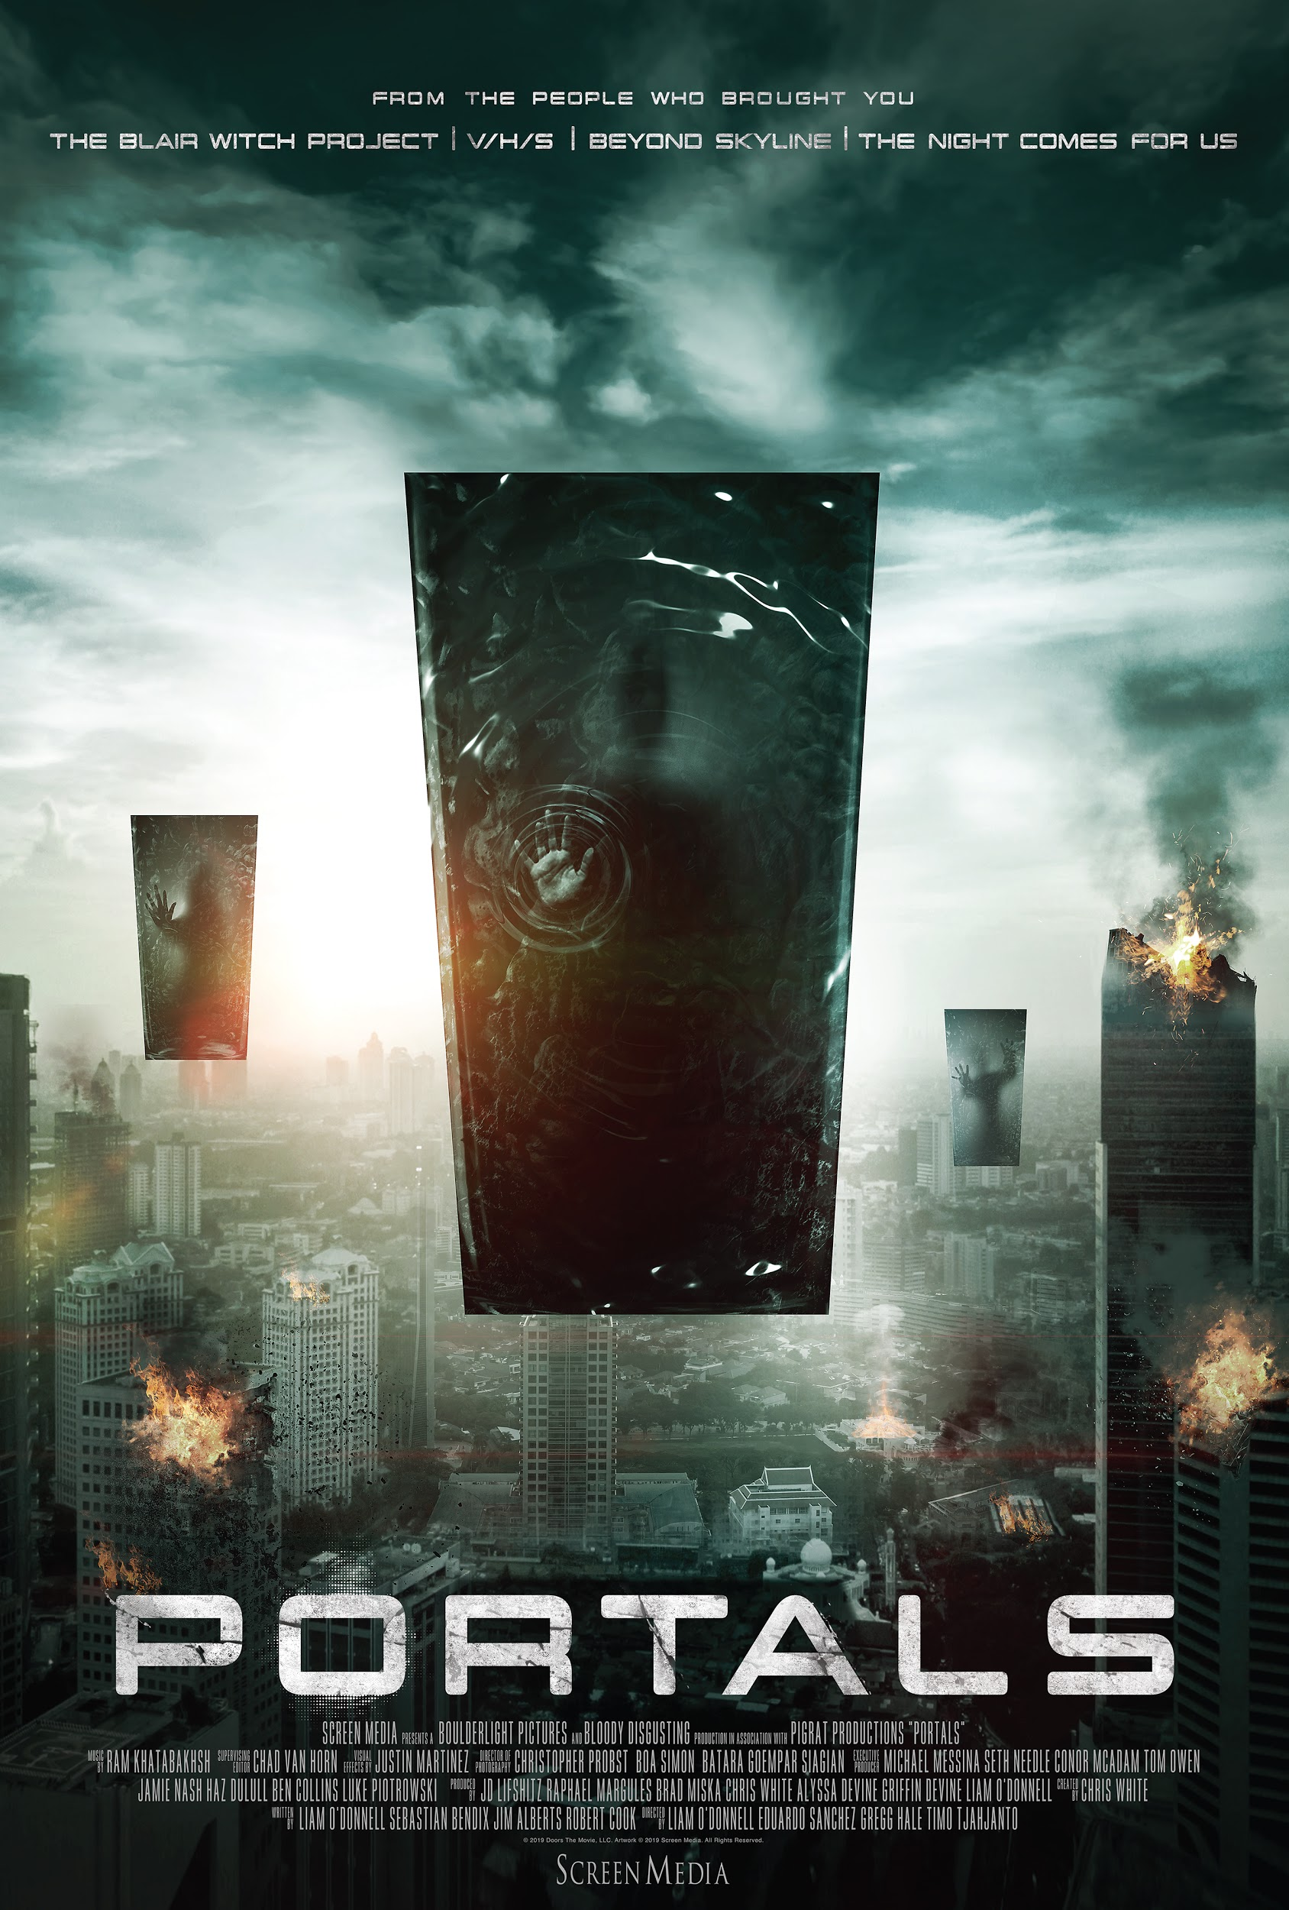
The Other Side Has Arrived

In Theaters and On Demand October 25

Directed by Eduardo Sanchez (The Blair Witch Project, Exists), Gregg Hale (V/H/S 2), Timo Tjahjanto (The Night Comes For Us, Headshot), and Liam O’Donnell (Beyond Skyline)
Starring Neil Hopkins (“Lost”), Deanna Russo (Burning Love, Knight Rider), Gretchen Lodge (Lovely Molly), Natacha Gott (After the Dark), Phet Mahathongdy (Skyline), Ptolemy Slocum (“Westworld”), and Salvita Decorte (The Night Comes For Us)

Produced by Brad Miska and creator Chris White alongside BoulderLight Pictures’ J.D. Lifshitz and Raphael Margules, and Pigrat Productions’ Alyssa and Griffin Devine

RT: 80 min

For additional information, please contact:
Falco Ink.
212-445-7100
Steve Beeman / StevenMBeeman@falcoink.com
Sam Prete / SamPrete@falcoink.com
LOGLINE

A sci-fi anthology from four iconic horror directors, tied together by a single event—the appearance of cosmic portals around the world. While many flee from them, the real terror sets in when others are drawn into these mysterious voids…

SYNOPSIS
On August 5th 2020, an undisclosed research facility successfully creates the world's first active black hole...Shortly after a cosmic disruption occurs triggering a series of world-wide blackouts; after which millions of mysterious, reality-altering, Portal-like anomalies appear everywhere and anywhere across the planet. While many flee from the sentient objects, the real terror sets in as people are drawn toward and into them.

Portals is a genre-bending anthology featuring three internationally connected stories told from four visionary filmmakers perspective as the cosmic events unfold within the first few days. The action quickly kicks off with our wrap around story following Adam and his family on their way to his mother-in-law's house during the blackouts and reports of missing persons..during the road trip their SUV barrels directly into an Anomaly that suddenly appears in the middle of a desolate road. He later wakes up in a mysterious hospital suffering from optic nerve damage and is given an experimental eye transplant that links itself directly to the anomalies. With a determination to be reunited with his family; Adam soon discovers the hospital has cosmic secrets of its own.

CAST BIOS

Neil Hopkins
Neil Hopkins is best known for his recurring role on the legendary series "Lost", as Liam, the junkie rockstar brother of Charlie (Dominic Monaghan). His other TV credits include recurring roles on the Emmy Nominated "Big Love" and the Lifetime series "Witches of East End", and a wide variety of guest starring roles on "Grimm", "True Blood", and "The Mentalist" to name a few. In 2013 Neil received rave reviews in for his work in the indie feature "Detour," which he also co-produced. In 2015, Neil starred in the series “Matador” for Producer Roberto Orci and Director Robert Rodriguez.
He is also the co-creator of the comedy webseries "Neil & John" (with long-time collaborator John Forest). In 2015 Neil and John began work on their first long form series D-SIDES in which they write, star and perform all the music.

In 2019 Neil is set to appear as ‘Lawrence Crock’ aka Sportsmaster in the highly anticipated series STARGIRL based on the DC Comics opposite Luke Wilson, Joel McHale and Brec Bassinger.

Ptolemy Slocum
Multi-faceted & brilliant character actor Ptolemy Slocum broke into the world of TV and film through such a diverse array of programming as David Simon's THE WIRE & David Chase's SOPRANOS for HBO, MTV's ground-breaking and irreverent WONDER SHOWZEN and the feature film HITCH starring Will Smith.
He was recently featured in the Oscar nominated VICE starring Christian Bale and directed by Adam McKay andhas continued to amass a wide range of television credits appearing on BASKETS (FX), VEEP (HBO), MARRIED (FX), NURSE JACKIE (Showtime), FRINGE (Fox), WORKAHOLICS (Comedy Central), BURN NOTICE (USA) and many others. Recurring roles include Andrew Haigh's LOOKING (HBO), Seth Rogen and Evan Goldberg's PREACHER (AMC), Marvel's INHUMANS and MAN IN THE HIGH CASTLE (Amazon). Most notoriously, he can be seen recurring as lab tech "Sylvester" on HBO's highly acclaimed and Emmy-nominated WESTWORLD. He is a SAG Award nominee along with his cast for Best Ensemble.
In addition, he has founded an improv school with NERDIST, voiced roles for Grand Theft Auto and worked opposite Billy Crystal for Funny or Die.

FILMMAKER BIOS

Timo Tjahjanto (director, “SARAH”)
Timo born in 1980 has been fascinated with film since an early age. He admitted watching Psycho at young age and has left him with “strong impression and somehow transform it into passion.” Akira Kurosawa, Martin Scorsese, Roman Polanski are some of the filmmakers who have influenced and shaped his film appreciation and creative ideas. After returning from his studies in Australia his first feature film project as a director was Rumah Dara (Macabre) in 2007, Timo co-directed this along with Kimo Stamboel together they are known as the Mo Brothers. Rumah Dara is the feature film based on “Dara” – a slasher/black comedy short film that he shot in 2008 which was released with other short horror films in horror compilation Takut: Faces of Fear in 2009. Rumah Dara was also one of the official selection features at PiFAN – International Fantastic Film Festival in 2009 in South Korea. He has gone on to direct acclaimed genre films: MAY THE DEVIL TAKE YOU and NIGHT COMES FOR US and has contributed segments to the popular horror anthologies ABC’s of DEATH and V/H/S 2.

Gregg Hale (co-director, “CALL CENTER”)
Gregg was born in Selma, Alabama, but lived most of his childhood in Henderson, Kentucky, which he considers his hometown. While attending Henderson County High School, he wrote plays, acted in school productions, co-founded a theater company that produced plays for children, came in second in a state-wide speech and drama competition for high school students, and played a lot of Dungeons and Dragons. After many years of dreaming of attending the University of Southern California School of Cinematic Arts, financial realities set in and lead him, instead, to Western Kentucky University. In his freshman year, he participated in numerous theatre productions and won the theatre and dance department's most prestigious award. Feeling unchallenged, he changed course after just one year of college and, in 1985, joined the Army, attending the Department of Defense Defense language Institute to study Persian-Farsi and graduating from Army Survival School. He was stationed with a Special Forces group as an Intelligence specialist. After four years, he was honorably discharged with enough resources to attend film school. He moved to Orlando, Florida and went to film school at Valencia Community College and the University of Central Florida. He worked as a set dresser and prop man on features and TV shows in Orlando and Los Angeles for 10 years before producing The Blair Witch Project, which established the "found footage" or "cinema scarité" as a popular film genre. As of 2013, he lives in Portland, Oregon.

Eduardo Sanchez (co-director, “CALL CENTER”)
Eduardo Sanchez was born in Cuba in 1968. It was at a young age he gained an interest in filmmaking. At Wheaton High School Ed made school movie projects such as Shrimp Fried Vice and Pride (in the name of Love) all of which starred his friends and family, as well as Ed himself.

After High School Ed studied at Montgomery College where he continued to make movies like Star Trek Demented. He later got accepted to the University of Central Florida where he made Gabriel's Dream, a film which he thought was going to be his big break, but that didn't come for almost another decade. In 1997 he and a close friend Daniel Myrick got together and started production on the most successful movie (budget to gross) ever, The Blair Witch Project (1999). It was a world-wide hit and has become one of the most spoofed films of all time.

Liam O’Donnell (director, “THE OTHER SIDE”)
A 2004 Boston University graduate, the following year Liam began working with visual effects pioneers Greg and Colin Strause on their music videos, commercials and films including Alien vs. Predator: Requiem (2007) and Skyline (2010), which Liam produced and co-wrote.
In 2017, Liam wrote his directorial debut, Beyond Skyline for its eventual star, Frank Grillo. The science fiction adventure was shot in the streets of Los Angeles, the subway tunnels of Toronto, and the jungles of Indonesia. As a director Liam combined his decade plus of experience in visual effects with extensive in-camera set pieces, stunt work, and martial arts with his stars and choreographers, Iko Uwais and Yayan Ruhian.
In 2019, Liam returned to write and direct the third installment titled Skylines, starring Lindsey Morgan, Jonathan Howard, Rhona Mitra, Daniel Bernhardt, Alexander Siddig, and James Cosmo. He recently wrapped principal photography in Vilnius, Lithuania. Produced by Matthew Chausse, Skylines is set for a late 2020 release through Vertical Entertainment.
Earlier this year, Liam shepherded Screen Media’s science-fiction anthology Portals, from the producers of the V/H/S films. Working alongside acclaimed genre filmmakers Eduardo Sanchez, Gregg Hale, and Timo Tjahjanto, Liam wrote, directed, and produced “The Other Side” segments starring Neil Hopkins.
Currently, Liam is attached to direct the post apocalyptic martial arts adventure The Last Savage, which he co-wrote with executive producer Derek Kolstad, writer and creator of the John Wick trilogy.

Chris White (Creator, Producer)
Chris White served as a Network producer on the hit MTV horror franchise “MY SUPER
PSYCHO SWEET 16”. Due to the original film’s positive reception, a “MY SUPER PSYCHO
SWEET 16” sequel was made and premiered in October 2010 followed by the third and final
installment in 2012. Later he would co-produce MTV's spring break thriller "THE TRUTH BELOW". Along with his work at MTV, Chris served as a segment producer for ‘D Is For Dogfight’ featured in the highly anticipated horror anthology feature “THE ABC's OF DEATH” which premiered at the 2012 Toronto International Film Festival followed by a theatrical release in 2013. Chris joined multi-media company The Collective at the start of 2013 and supervised production, development and acquisitions as part of the Salient Media division. He executive produced V/H/S: VIRAL the third installment of the successful found footage anthology feature film, V/H/S. Chris also oversaw the acquisition of films for the
Bloody-Disgusting Selects series of independent horror films. Currently, Chris has a project in scripted development with Oscar-winning producer/director Lee Daniels (EMPIRE, THE BUTLER) titled ICED based on the critically acclaimed novel of the same name and a new Sci-Fi anthology PORTALS as creator/producer with the creative team behind V/H/S, The Blair Witch Project, The Night Comes For Us & Beyond Skylines..As well as co-creating a new television series with the BAFTA-Winning UK based production company Sugar Films.

Brad Miska (Blood Disgusting)
Bloody Disgusting is the world’s largest destination for horror fans, with an audience of over 20 million. Trusted since 2001 as the first source for breaking and in-depth coverage of all things horror, the Chicago-based media company produces its award-winning namesake website and mobile app, the fastest growing weekly horror show on YouTube, “This Week in Horror,” and the number one podcast network for horror fans. Bloody Disgusting has also both produced and distributed films, including Sundance Film Festival hits V/H/S, V/H/S/2, and THE WOMAN, as well as the TIFF Midnight Madness breakout SOUTHBOUND. Bloody Disgusting has positioned itself as the most important place for producers of genre film, television, games, events, and comics to connect with their fans. For more information, please visit www.bloody-disgusting.com

BoulderLight Pictures
J.D. Lifshitz and Raphael Margules launched BoulderLight Pictures in 2012 with the production of body horror hit CONTRACTED, a major theatrical and VOD hit for IFC Midnight that was quickly followed by a sequel. Over the following years, BoulderLight continued to grow its production arm with a number of genre films and expanded to work alongside global leaders in the industry. Their psychological thriller DISMISSED, starring Dylan Sprouse, was produced as part of a 3-picture slate deal with Making Film Productions LTD - one of Hong Kong’s most prominent entertainment companies - and their tinder-based thriller BAD MATCH was a co- production with MM2 Entertainment, Singapore’s leading media company. In 2014, BoulderLight launched its international sales arm at Cannes Film Festival. BoulderLight’s most recent release, fraternity horror film, PLEDGE, premiered at the Fantasia Film Festival, and was released by IFC Midnight in January 2019. Concurrently with the release of PORTALS, BoulderLight is finishing their latest film: an elevated Jewish-Folklore horror film that takes place within the New York City hassidic community, produced alongside the Spirit Award nominated team behind MENASHE; as well as heading into production on the über-stylish thriller BECKY, directed by Cannes and Sundance alum Jonathan Milott and Cary Murnion (BUSHWICK, COOTIES) and starring Kevin James (PAUL BLART franchise, King of Queens) and Lulu Wilson (HAUNTING OF HILL HOUSE, ANNABELLE franchise).

PigRat Productions (Producers)
Alyssa Radmand Devine and Griffin Devine are a Los Angeles based filmmaking team. Their award-winning short films have been played at film festivals around the world and they’ve contributed two films to Eli Roth’s popular horror channel CryptTV that have received millions of views online. Through their production company PIGRAT PRODUCTIONS they champion stories written by diverse filmmakers and have produced three feature films to date: THE WORKOUT ROOM, RECOVERY, and PORTALS, all set to be released in 2019.
Prior to launching PigRat, Griffin spent time working at Variety and Alyssa worked at Double Feature Films as the assistant to Stacey Sher on the blockbuster pictures CONTAGION, and DJANGO UNCHAINED.

Hasraf ‘HaZ’ Dulull (Executive Producer)
Hasraf ‘HaZ; Dulull is known for his breakout sci-fi indie feature film - THE BEYOND, which was released by Gravitas Ventures, and premiered at #2 on the iTunes charts before trending on Netflix. His second feature film 2036: ORIGIN UNKNOWN, which starred Katee Sackhoff (Battlestar Galactica) earned a limited theatrical release in the US.
He was later hired to direct the pilot for Disney’s action-comedy mini-series - FAST LAYNE, and was also credited as creative consultant on the entire series and directed three additional episodes when he wowed Disney channel executives with his vision for the 8 part series.
HaZ is repped by Paradigm and The Gotham Group, and is the co-founder of production company HaZ Film.

