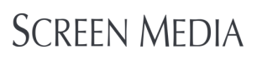
Presents

THE SONATA
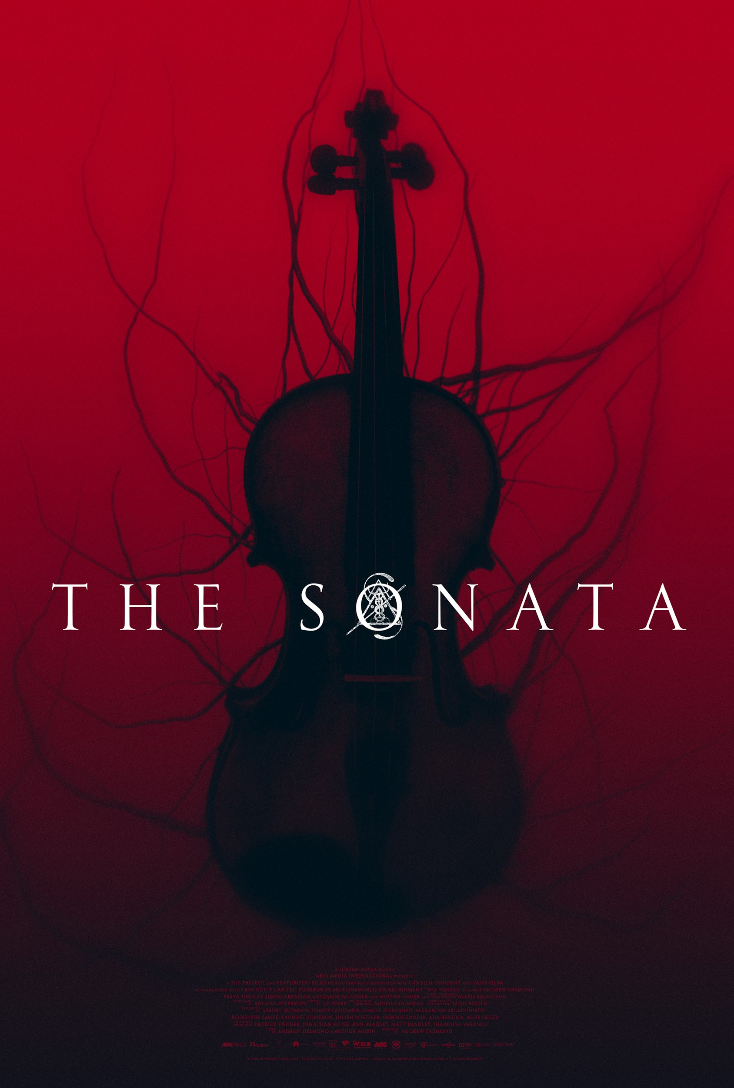

In Theaters and On-Demand January 10th

Starring: Freya Tingley, Rutger Hauer, Simon Abkarian, James Faulkner

Director: Andrew Desmond

*Scary Movies at Lincoln Center Official Selection*
After being informed of the sudden death of her long lost composer father (Rutger Hauer), a young virtuoso violinist Rose (Freya Tingley) inherits an old mansion in which he used to live. There, she discovers her father’s final work: a mysterious music score marked with strange symbols. With the help of Charles (Simon Abkarian), her agent and manager, she deciphers the symbols and, little by little, starts to unlock secrets concerning her father’s past, setting in motion the mechanisms of a somber plan imagined since the very day she was born. They soon discover that there’s more to the sonata in question than meets the eye which, when played, triggers and unleashes dark and terrifying forces.

RT: 88 min

Download Poster | Download Stills

Publicity Contacts:
Falco Ink. | 212-445-7100
Steven Beeman, StevenmBeeman@FalcoInk.com
Adrianna Valentin, AdriannaValentin@FalcoInk.com

