Presents

GOLD
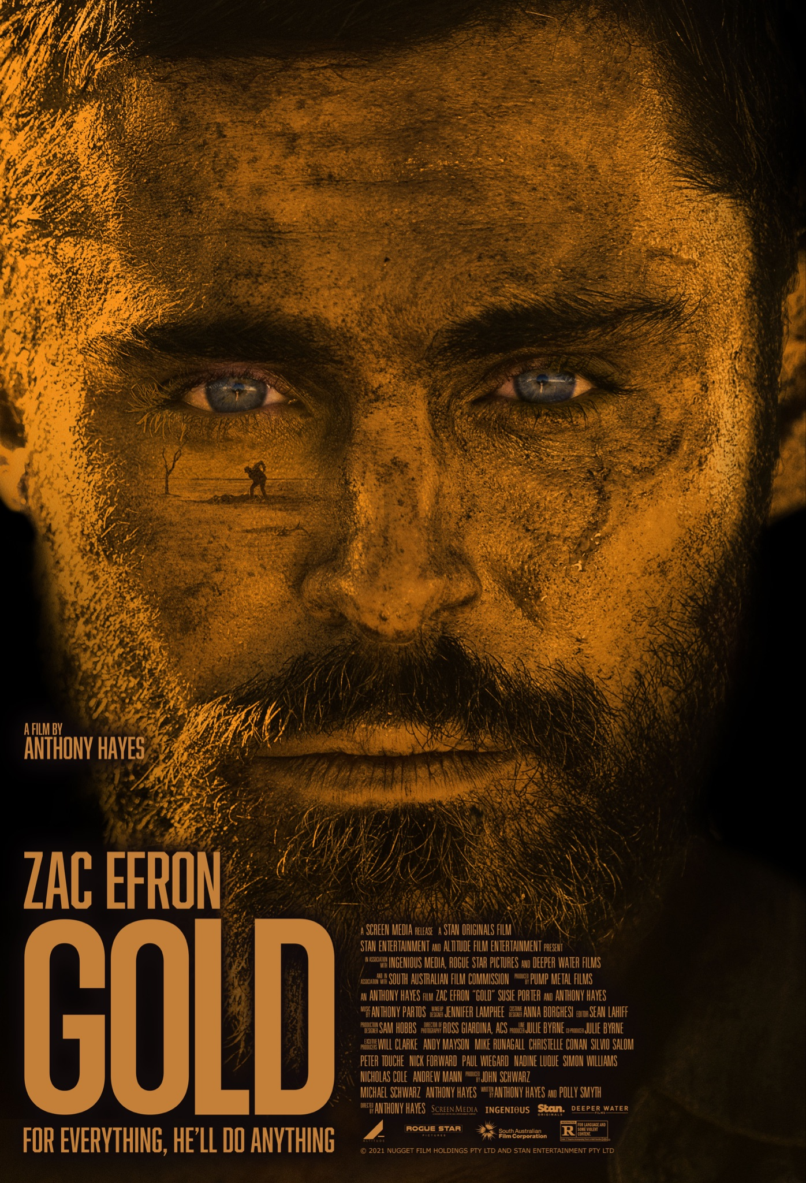
Available In Theaters March 11th

Directed by Anthony Hayes
Written by Anthony Hayes and Polly Smyth
Starring Zac Efron, Susie Porter and Anthony Hayes

RT: 96 Minutes

Publicity Contacts
Falco Ink.
Adrianna Valentin | AdriannaValentin@Falcoink.com
Robyn Butler | RobynButler@Falcoink.com
SYNOPSIS
In the not too distant future, two drifters (Zac Efron, Anthony Hayes) traveling through the desert stumble across the biggest gold nugget ever found and the dream of immense wealth and greed takes hold. They hatch a plan to excavate their bounty with one man leaving to secure the necessary tools. The other man remains and must endure harsh desert elements, ravenous wild dogs, and mysterious intruders, while battling the sinking suspicion that he has been abandoned to his own fate.

ZAC EFRON Q&A

How would you describe Gold?

Gold is a story about temptation and about greed and about the lengths to which we all go in various ways to get what we want - and the lengths my character goes through to persevere extreme conditions just to hold on to what he thinks he needs.

What attracted you to the project?

When I read the script, I was really struck by how different it was and how little dialogue there was. I genuinely fell in love with it, imagining this person that we don't really know, make very complex choices throughout the movie, and sort of adapt and, and try to survive.

It reminded me of an old Western in, in some ways, it had a very classic movie feel to it. There’s not too much talking, and we never really find out too much about the character. It leaves a lot open to the audience to interpret, which I loved. It’s a very complex and an intelligent piece of work

I love survival stories and the simplicity of watching somebody try and figure out living in the wild or surviving in the wild. All of those elements combined made me very interested in playing the part.

What can you tell us about your character?

You don't ever really find out too much about him. It's very clear that when he arrives, he's searching for new beginnings in some capacity, and he has gone somewhere completely off grid to look for an opportunity to start afresh.

As soon as he steps off the train platform, at the beginning of the movie, he's definitely in over his head. I don't think that he's at all prepared for what lies in store for him. He's kind of shy. We don't really know where he came from or where he's really truly trying to head to. But he's clearly come from a scarred past and is either running from something or trying to start anew.

Tell us about filming in the middle of Summer in the South Australian outback?

Unbelievable! I've never been anywhere quite like it, to be honest. I didn't know what to expect but it's just unbelievably beautiful and mesmerizing, but also very desolate, dry and harsh. Filming a movie in such a remote location is complicated but at the same time – easier in some ways. Once you commit to being out there, there's no real connection with the outside world. Like, there's no cell phone signal! There's no Wi-Fi, no creature comforts.
I enjoy that because I get to disconnect from the outside world, and just focus on the material – and that's really fun.

The elements were brutal. I think it's one of the hardest filming conditions I've ever been in. The heat is non-stop. The sun is scorching. The ground is unbelievably hot, and just reflects all the light up into you. Then there were other challenges - for instance we had massive dust storms that luckily kind of found their way into the movie.

But they definitely pushed our crew to the limit, and they pushed everybody to the limit. We filmed through some of the gnarliest conditions I've ever witnessed in my life - and it was awesome!

Tell us about working with Anthony Hayes?

Anthony is fantastic! It’s gratifying to work with somebody who has written the script and knows the material so well and is also in the movie with you.

It was really cool to watch him work. I feel like I'm learning a lot, and he's kind of inspired me to push myself not just as an actor but think about what it means to be a writer as well as a director. It was fun to watch him problem solve, while he's in his character wardrobe and direct the movie.

I think this is going to be one of his coolest things yet, which is saying a lot.

And Susie Porter?

Susie's just lovely and so fun to work with. The character that she plays, is really interesting. She plays two characters over the course of the movie and definitely took it to a place that I wasn't anticipating… so far beyond and into a really beautiful place.

Susie is such a professional and I think this is probably the farthest she's gone, into this level of extreme, for a character.

So it was really fun to watch her and work with her and she's just lovely off-screen.”

What do you hope audiences take away from the film?

I think one of my favorite things about the film and that I hope the audience can take away is that nature has a way of taking everything back or leveling everything out in the end.

If we keep coveting things that we do as humans – money and power and things of that nature that, we're eventually going to be taking too much away from the planet

So, hopefully we can learn to, to become more one with, with the world, and one with nature, and, and to live within it, instead of trying to take from it as much.

What I hope audiences would take away from the film is actually summed up in this quote from the Indigenous peoples here in Australia …

If we continue to defy the natural order of things, in a quest for material wealth, Mother Earth will retaliate, the whole environment will retaliate, and the abusers will be eliminated. Things will come back full circle, back to where they started. This is the prophecy of all indigenous peoples.

CAST BIOS

ZAC EFRON
Nurturing an impressive body of work that encompasses both film and television, Zac Efron has proven to be one of Hollywood’s most sought-after talents.

Recent credits include Netflix’s Down to Earth with Zac Efron, in which he also served as an executive producer. In this travel show, Efron journeys around the world with wellness expert Darin Olien in search of healthy, sustainable ways to live. In 2020, Zac was also featured as one of the voices in the hit Warner Bros. animated movie, Scoob!,alongside Will Forte, Mark Wahlberg, and Amanda Seyfried. In 2019, he starred in crime-thriller Extremely Wicked, Shockingly Evil and Vile, in which he plays the notorious serial killer, Ted Bundy. The film premiered at the 2019 Sundance Film Festival and Zac received rave reviews for his portrayal of Bundy.

In 2017, Zac starred in The Greatest Showman, alongside Hugh Jackman and Michelle Williams. The film follows the story of American showman P.T. Barnum, founder of the famous traveling Ringling Bros. and Barnum & Bailey Circus. The critically acclaimed film was awarded a range of accolades including a Golden Globes nomination for Best Motion Picture - Musical or Comedy. Zac also co-starred opposite Dwayne Johnson in Baywatch, a comedy based off the popular TV show.

Additionally, he was seen in The Disaster Artist, a dramedy directed by and starring James Franco about the making of Tommy Wiseau’s The Room, which premiered to rave reviews at the 2017 South by Southwest Film Festival and went on to receive numerous awards. Additional film credits include Mike and Dave Need Wedding Dates with Adam Devine, Neighbors 2: Sorority Rising, the sequel to the comedy Neighbors, alongside Seth Rogen, Dave Franco and Rose Byrne; Dirty Grandpa with Robert De Niro; Max Joseph’s We Are Your Friends; Lee Daniels’ The Paperboy, alongside Nicole Kidman, John Cusack and Matthew McConaughey; Liberal Arts, an independent film written and directed by Josh Radnor; The Lucky One, a film adaption of the Nicholas Sparks novel; the NBC Universal animated film Dr. Seuss’ The Lorax; Gary Marshall’s New Year’s Eve; Charlie St. Cloud; 17 Again; the Richard Linklater film Me and Orson Welles; and the box office smash summer film Hairspray, which won the Critics’ Choice award for Best Ensemble.

Television credits include a recurring role on the WB series “Summerland,” plus guest roles on ER, The Guardian and C.S.I. Miami. Efron became a household name with the launch of the 2006 Emmy Award-winning Disney Channel phenomenon High School Musical. He reprised his role as Troy Bolton, head of the basketball team, in High School Musical 2, which broke cable TV records garnering 17.5 million viewers. Zac also starred in the Disney Feature Film High School Musical 3: Senior Year, the third instalment of the franchise. HSM3 set a box office record as the highest grossing opening weekend total for a musical.

Zac has received a wide array of accolades throughout his career including CinemaCon’s Comedy Star of the Year(2016), ShoWest’s Breakthrough Performer of the Year award, the MTV Movie Award for Breakthrough Performance(2008) and Best Male Performance (2009), in addition to multiple People’s Choice, Teen Choice and Kids Choice Awards.

On stage, Zac starred in the musical Gypsy, and has appeared in productions of Peter Pan, Mame, Little Shop of Horrors and The Music Man. In addition to acting, Zac established his own production company, Ninjas Runnin’ Wild, with Jason Barrett and Michael Simkin in 2010. Ninjas Runnin’ Wild is currently developing various film and television projects with multiple studios.

ANTHONY HAYES
Anthony has appeared on our film and television screens for over 30 years, with film credits including Robert Connolly’s The Boys, Phillip Noyce’s Rabbit Proof Fence, Bootmen alongside Sam Worthington, Ned Kelly with Heath Ledger, the local independent feature West, and David Michod’s multi award winning debut feature Animal Kingdom.

It was Anthony’s performance as Stevie in the acclaimed Australian feature film The Boys that earned him Australian Film Institute (AFI) and Film Critics Circle of Australian (FCCA) nominations as Best Supporting Actor in 1998. He went on to win an AFI award in 2005 for Best Supporting Actor for Look Both Ways and followed with another win in 2006 for Suburban Mayhem. Other nominations include AFI and FCCA Best Supporting Actor nominations for his role in Nash Edgerton’s The Square.

Anthony’s extensive body of work in television includes the role of Gary in the acclaimed BAFTA nominated ABC series The Slap, alongside Anthony LaPaglia, Alex Dimitriades and Melissa George, which saw him nominated for Best Actor at the 2012 Festival de Television de Monte Carlo, the ABC mini-series Bastard Boys the six part ABC series Changi, and guest roles in numerous and well known Australian series including Rush, Sea Patrol, McLeod’s Daughters, Water Rats and Blue Heelers.

Along with acting, Anthony has developed a career in writing and directing. His debut feature film Ten Empty had its world premiere at the Sydney Film Festival in 2008 and received nominations for Best Screenplay at the Victorian and the Queensland Premier’s Literary Awards in 2008 and 2007 respectively. In 2002 Anthony also wrote, produced, and directed the short feature New Skin which won several awards including the prestigious Dendy Award at the Sydney Film Festival, and the Independent Film (IF) Award for Best Emerging Director. In 2001 he was also the recipient of a grant from the Gloria Payten and Gloria Dawn Fellowship which enabled him to travel to the UK to spend time with director Mike Leigh.

SUSIE PORTER
Susie Porter has built a reputation as one of Australia’s most outstanding actors. Her remarkable list of credits includes feature films Summer Coda, Bootman, Better Than Sex, Mullet, Paradise Road, Idiot Box, Two Hands, Feeling Sexy, Monkey’s Mask, Teesh and Trude, the award-winning Little Fish, The Caterpillar Wish and The Turning: On Her Knees. Porter was most recently seen in the critically acclaimed Ladies in Black, The Second, Cargo, Don’t Tell and Hounds of Love.

Renowned for her exceptional performances across a diverse range of unforgettable characters on the small screen, Porter appears as the calculating and ruthless criminal ‘Marie Winter’ in Wentworth (Series 6-8). She played the lead role in East West 101 (Series 1 - 3), East of Everything, RAN, My Place, Love My Way, The Secret Life of Us, The Jesters (Series 1 and 2), Sisters of War and Underbelly: Squizzy. Other television appearances include the ABC’s excellent mini-series Seven Types of Ambiguity, Pulse and Janet King Series 3; Network Ten’s bikie drama Brothers in Arms; the family series Puberty Blues (Series 1 and 2); the comedies Problems and It’s a Date (Series 2); the telemovie Dangerous Remedy and the Matchbox Productions’ mini-series Hungry Ghosts for SBS. Coming up next will be the mini-series The Unusual Suspects, also for SBS.

Porter has worked with many major theatre companies and her most recent theatre credits include the critically acclaimed Summer of the Seventeenth Doll and That Face.

Porter has been widely acknowledged by her peers and the public with multiple AFIs, IF Awards, Logie Awards and AACTA and FCCA nominations for her work.

FILMMAKER BIOS
JOHN AND MICHAEL SCHWARZ, Producers, Deeper Water Film
John and Michael Schwarz first established themselves as Full Clip Productions in 2010, alongside Sam Worthington. The company was started to produce stories across a diverse cross section of mediums, including feature films, television, graphic novels and digital platforms.
Their first graphic novel, Damaged, debuted in 2011 to critical acclaim and is now being developed as a television series.
In 2011, Full Clip launched their TV division with a first look deal at NBCU International, which led to the 2015 critically lauded tv event miniseries, Deadline Gallipoli, based on the WWI campaign. Directed by Michael Rymer and staring Sam Worthington, Hugh Dancy and Charles Dance, the mini-series was nominated for best writing in original television mini-series at the 2015 Australian Writers Guild Awards.
Two seasons of the digital series Cleaners were produced for Crackle, the online-video network of Sony Pictures Television. Written and directed by Paul Leyden, Cleaners had a cast that included Emanuel Chriqui, Emily Osment, David Arquette and Gina Gershon).
2017 saw the release of the feature film Hunter’s Prayer (based on the novel For The Dogs by Kevin Wignall), directed by Jonathan Mostow, with a script by John Brancato & Michael Ferris and staring Sam Worthington and Odeya Rush.
John and Michael have since gone on to form a new company in Deeper Water Films. The first film under the was banner was Killerman, written and directed by Malick Bader and featuring Liam Hemsworth, Emory Cohen and Diana Guerrero.
The second completed film production and was the award-winning Danger Close: Battle of Long Tan, written by Stuart Beattie, directed by Kriv Stenders and starting Travis Fimmel Luke Bracey and Richard Roxburgh. It received a wide theatrical release in August 2019.
2019 also included the airing the ABC series, Les Norton. Based on the iconic Australia book series by Robert G. Barrett, it stared Alex Bertrand, Rebel Wilson and David Wenham.
As of September, 2020, Deeper Water Films are currently filming one of the first feature films to be back in production in Australia after the COVD-19 pandemic with Bosch and Rockit, staring Luke Hemsworth and Isabel Lucas.

Following Gold, Deeper Water will go into production of Transfusion, with Matthew Nable directing and Sam Worthington in the lead role.

ROSS GIARDINA, Director of Photography
Ross Giardina is an International Award-winning Cinematographer / Director of Photography specialising in Film, Commercials, Music Videos and Documentary.

His feature credits include The Dressmaker (second unit); Catch The Fair One and Significant Strangers.

In 2019, the short Carl’s Motel was in Official Selection at the Madrid International Film Festival and LA Shorts International Film Festival.

Ross is a triple Golden Tripod winner at the Australian Cinematographer’s Society Awards for his advertising work.

SAM HOBBS, Production Designer
Sydney based Sam Hobbs is one of the most respected and hardest working Production Designers in Australia. Sam has more than 20 years experience as a Production Designer and Art Director across film, television, theatre and marketing/advertising.

Sam’s recent work includes Danger Close: The Battle of Long Tan; Abe Forsythe’s feature film Little Monsters; Kriv Stender’s Red Dog: True Blue and the acclaimed feature length documentary The Waler: Australia’s Great War Horse.

Sam’s television credits include the award-winning The Kettering Incident and many other series such as Pulse, Old School, Janet King, Rescue Special Ops, Australia: The Story of Us, Hyde & Seek and The Alice.

In 2017 Sam was nominated for the APDG (Australian Production Designers Guild) award for best production design for a feature film for his work on the 19th C period epic Hanyut, an adaptation of Joseph’s Conrad’s novel Almayers Folly directed by U-Wei bin Haji Saari shot in Malaysia.

Sam also has extensive production design/art direction experience for television commercials including three years of work for the ANZ Bank’s award-winning annual support of the Sydney Gay and Lesbian Mardi Gras event via the Whybins agency.

ANNA BORGHESI, Costume Designer
Anna Borghesi is an award-winning costume designer with over 25 years’ experience in film, television and theatre.
Her film credits include Hotel Mumbai (dir. Anthony Maras, 2018), Ali’s Wedding (dir. Jeffery Walker, 2017), Red Dog: True Blue (dir. Kriv Stenders, 2016), Sucker (dir. Ben Chessell, 2015), The Killer Elite (dir. Gary McKendry, 2011), Mao’s Last Dancer (dir. Bruce Beresford, 2009), The Condemned (Scott Wiper, 2007), The Book of Revelation (dir. Ana Kokkinos, 2006), Love’s Brother (dir. Jan Sardi, 2004), Ned Kelly (dir. Gregor Jordan, 2003) - for which she won the AFI Award for Best Costume Design, Darkness Falls (dir. Jonathan Liebesman, 2003), Mr Accident (dir. Yahoo Serious, 2000), Pitch Black (dir. David Twohy, 2000), Head On (dir. Ana Kokkinos, 1998), The Well (dir. Samantha Lang, 1997), Love Serenade (dir. Shirley Barrett, 1996), Metal Skin (dir. Geoffrey Wright, 1994), Paperback Romance (dir. Ben Lewin, 1994), Body Melt (dir. Phillip Brophy, 1993), and Romper Stomper (dir. Geoffrey Wright, 1992).
Her television credits include Romper Stomper (2017) for STAN, Lowdown (2012), Twentysomething (2011), Tangle (2009), The Outsider (2002), Child Star: The Shirley Temple Story (2001), On the Beach (2000) and SeaChange (1998).
Anna has worked extensively in theatre, designing costumes for Melbourne Theatre Company, Belvoir Street Theatre, Malthouse Theatre, Queensland Theatre Company and South Australian Theatre Company among others.
Most recently Anna designed the costumes for Hotel Mumbai (dir. Anthony Maras/ Cyan Films, 2019) and Dirt Music(dir. Gregor Jordan/ Aquarius Films), the adaptation of Tim Winton’s novel, which had its World Premiere at the 2019 Toronto International Film Festival.

CREDITS

Director: Anthony Hayes

Writers: Anthony Hayes and Polly Smyth

Director of Photography: Ross Giardina, ACS

Production Designer: Sam Hobbs

Costume Designer: Anna Borghesi

Make Up & Hair Designer: Jennifer Lamphee

Editor: Sean Lahiff

Sound Recordist: James Currie

Producers: John Schwarz
Michael Schwarz
Anthony Hayes
Co-Producer: Julie Byrne

Executive Producers: Andrew Mann
Peter Touche
Simon Williams
Paul Wiegard
Will Clarke
Andy Mayson
Nick Forward
Mike Runagall

